

ASSIGNMENT 1
Name | - Ahmad Faiz Fahmi Bin Ahmad Shah  - Naufal Al-Harith Bin Muhammad Fisol
Matric Number | - A25AI0013  - A25AI0037
Section | 07
Course Name | Machine Learning
Lecturer | Dr Marwan Hadri Azmi
Table of Contents

1.0 Dataset Collection 4
2.0 Supervised Learning Classification 5
2.1 Dataset Preprocessing 5
Overview 5
2.1.0 Resizing 5
2.1.1 Normalisation 5
2.1.2 Data Augmentation 6
2.2 Data Splitting 7
2.2.1 Overview 7
2.2.2 Split Ratio 7
2.2.3 Justification for 80/20 Split 8
2.3 Algorithm Selection 9
2.3.1 Overview 9
2.3.2 Why not plain CNN from scratch? 9
2.3.3 Why CNN? 9
2.3.4 Why MobileNetV2 (Transfer Learning)? 9
2.4 Model Training 10
2.4.1 Plain CNN 10
2.4.1.1 Model Architecture 10
2.4.1.2 Training Configuration 11
2.4.1.3 Training Results 13
2.4.3 Pretrained CNN - MobileNetV2 14
2.4.3.1 Model Architecture 14
2.4.3.2 Training Configuration 15
2.4.3.3 Training Results 16
2.5 Model Evaluation 17
2.5.1 Plain CNN Model Evaluation 17
2.5.2 Pretrained CNN(MobileNetV2) Model Evaluation 17
2.5.3 Comparison 18
2.5.4 Interpretation 18
2.6 Conclusion 19
3.0 Unsupervised Learning with K-Means 20
3.1 Preprocessing 21
3.1.1 Import Libraries And Load Dataset 21
3.1.2 Preprocessing: Flatten and Normalise 22
3.1.3 Choosing k with the Elbow Method 22
3.1.4 Apply K-Means Clustering (k = 2) 23
3.2 Cluster Comparison 25
3.2.1 Visualise Cluster Assignments vs Ground Truth 25
3.2.2 Confusion Matrix 26
3.2.3 Cluster Comparison: Sample Images 28
3.2.4 Reference Images and Final Summary 28
4.0 Reflection And Comparitive Analysis 30
4.1 Algorithm Comparison 30
4.2 Challenges 30
4.3 Supervised Model Performance 31
4.4 K-means output analysis 32
4.5 Future Improvement 33

Dataset Collection
This dataset is a simple cat and dog binary classification dataset with 2 categories, where the training set contains 275 annotated images and the validation set contains 70 annotated images.
Dataset Source : https://www.kaggle.com/datasets/marquis03/cats-and-dogs
Classes : 2 ( Cats vs Dogs )
Total images : 345 images

2.0 Supervised Learning Classification

2.1 Dataset Preprocessing

Overview
Machine Learning Models Need Cleaned Up And Standardized Before Feeding Them Images. Raw Photographs Have Various Widths And Heights, Conflicting Lightness Of Color,/etc. Preprocessing Creates Uniformity For All Photographs So That Learning Via Your Model Is Done Consistently.

2.1.0 Resizing
All images are resized to a fixed dimension of 128 x 128 pixels.
Why resizing is necessary?
- Neural networks need all inputs to be the same form. Without them being of regular size, batching images together is impossible.
- Photographs that have been taken in the real world will differ vastly in size, from small thumb images (100×80px) through to very high-resolution camera shots (4000×3000px). By resizing them to use a common input format you make it possible for the computer to process many photos at once.
- Smaller sizes (128×128 px vs 512×512px) will reduce the amount of time taken (and memory used) when generating the neural network during training.

2.1.1 Normalisation
Pixel values are rescaled from the range [0, 255] to [0,1] by dividing by 255.
Why normalisation is necessary?
- Raw pixel values (0-255) are large numbers that cause large gradient updates, making the model unstable and slow to converge during training.
- Normalised values (0-1) keep all features on the same scale, allowing the optimiser (Adam) to work efficiently and find the optimal weights faster.
- Most pretrained models like MobileNetV2 were trained on normalised data, so consistent preprocessing is essential for transfer learning to work correctly.

2.1.2 Data Augmentation
To combat overfitting caused by the small dataset (275 images), the following augmentation techniques were applied to the training data:

Technique | Parameter | Purpose
Random Rotation | rotation_range=20 | Teaches the model that tilted cats/dogs are still cats/dogs
Random Zoom | zoom_range=0.2 | Simulates photos taken at different distances
Horizontal Flip | horizontal_flip=True | Doubles variety by mirroring each image
Width Shift | width_shift_range=0.1 | Simulates off-centre framing
Height Shift | height_shift_range=0.1 | Simulates subjects at different heights in frame

Augmentation was applied to the training set only. The validation set uses only rescaling to ensure evaluation reflects real-world performance on unmodified images.

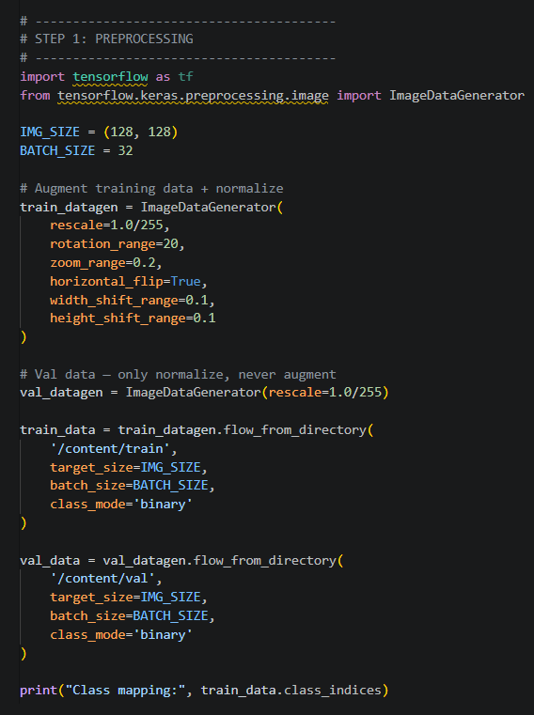
Figure 1 : Code for Data Preprocessing

2.2 Data Splitting

2.2.1 Overview
The dataset is divided into two subsets: a training set used to teach the model, and a validation set used to evaluate its performance on unseen data.

2.2.2 Split Ratio
Set | Images | Percentage | Purpose
Training Set | 275 images | 80% | Model learns patterns from these images
Validation Set | 70 images | 20% | Tests the model on images it has never seen
Total | 345 images | 100% | Full dataset

2.2.3 Justification for 80/20 Split
- The ratio of 80/20 is standard practice in the industry with respect to very small datasets, thus providing an approximate balance between training the model (learning features) and testing the model (evaluating generalisation).

- 80% of the data for training (275 samples) will provide sufficient examples for the model to form a basis to learn the features that distinguish cats from dogs.

- 20% of the data for validation (70 samples) will provide enough samples to ensure that the accuracy scores are statistically valid and reliable.

- The validation set provides a benchmark for the model, i.e. it gives a series of questions that the model did not learn from training; therefore providing an unbiased evaluation of the model's ability to generalise.

2.3 Algorithm Selection

2.3.1 Overview
Algorithm Chosen: MobileNetV2 (Convolutional Neural Network)

2.3.2 Why not plain CNN from scratch?
Requires thousands of images to train well, struggles with only 275 images.

2.3.3 Why CNN?
- CNN employs convolutional filters to slide across images for finding local patterns, searching for edges/curves (textured), while maintaining the spatial relationship of pixels.

- Each subsequent layer of CNN continues to learn progressively more complex features - (e.g., early layers detect edges; middle layers learn to recognize features like an 'ear' or 'eye'; deeper layers will eventually be able to identify entire animal face)

- Because of this hierarchical approach to feature extraction, CNN are particularly valuable in performing image classification.

2.3.4 Why MobileNetV2 (Transfer Learning)?
- MobileNetV2 has already been trained on ImageNet, which contains an overall 1.4 million photographs spread across a range of one thousand classes. The network has learned to identify textures, edge curvatures, shapes, and to detect objects.

- By taking advantage of these trained coefficients (base_model.trainable = False), we can avoid having to re-train from the beginning and use the feature extraction capabilities of the weights even using just 275 training images.

- Only the top classifying layers have been trained using the dog and cat datasets - by doing this we are reducing the overall time spent on the training exercise while still being able to produce more accurate results.

- The result of this new method has increased validation accuracy from the original 65% (from a plain CNN built from scratch) to 95.71% (from MobileNetV2 through transfer learning)

2.4 Model Training

2.4.1 Plain CNN

2.4.1.1 Model Architecture
Component | Details
Input Shape | (128, 128, 3)
Convolution Layers | 8 Layers (32, 64, 128, 256 layers, kernel size 3×3)
Activation Function | ReLU
Pooling Layers | MaxPooling2D (2×2) after each Conv layer
Fully Connected | Dense(512) → Dense(256)
Regularization | Dropout(0.25) in conv blocks, Dropout(0.5) in classifier; Batch Normalization throughout
Output Layer | Dense (1 unit, Sigmoid)

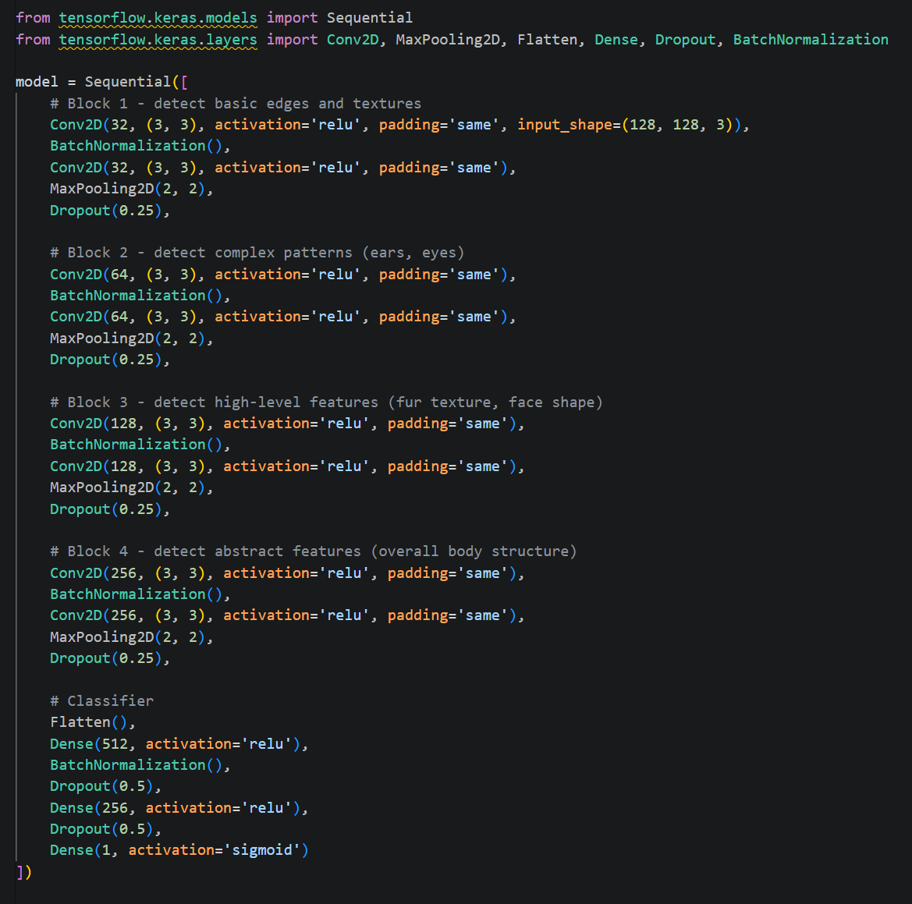
Figure 2 : Defining Plain CNN Architecture

2.4.1.2 Training Configuration
Parameter | Value
Optimizer | Adam
Loss Function | Binary Crossentropy (For 2 class problems)
Metrics | Accuracy
Batch Size | Not specified
Epochs | 20 (Early stopped at ~6)
Early Stopping | Yes (patience = 3, monitor = val_loss)
Learning Rate | Default Adam

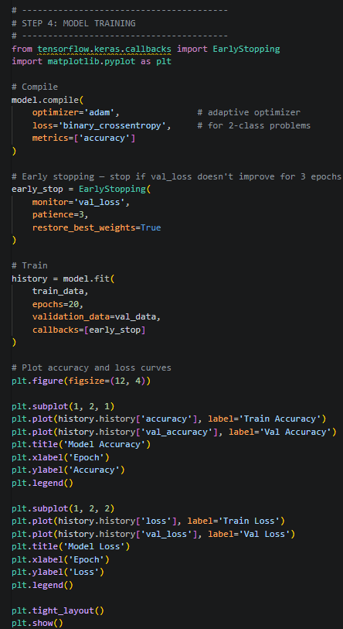
Figure 3 : Plain CNN Model Training
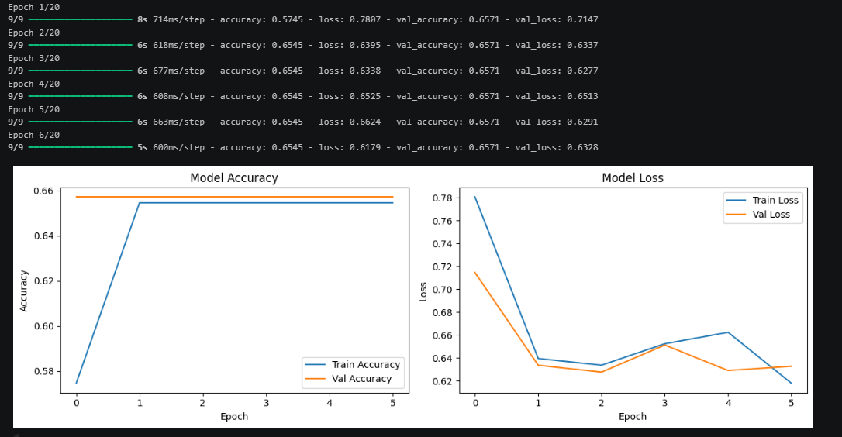
Figure 4 : Plain CNN Model Training Results

2.4.1.3 Training Results
Metric | Training | Validation
Accuracy | ~0.6545 | ~0.6571
Loss | ~0.6179 | ~0.6328
Precision | 0.6571 | 0.6571
Recall | 1.0000 | 1.0000
F1-Score | 0.7931 | 0.7931

2.4.3 Pretrained CNN - MobileNetV2

2.4.3.1 Model Architecture
Component | Details
Base Model | MobileNetV2
Input Shape | (128, 128, 3)
Pretrained Weights | ImageNet
Trainable Layers | Top classifier only
Frozen Layers | Entire base model
Feature Extraction | GlobalAveragePooling2D
Fully Connected | Dense (128 units, ReLU)
Regularization | Dropout (0.3)
Output Layer | Dense (1 unit, Sigmoid)

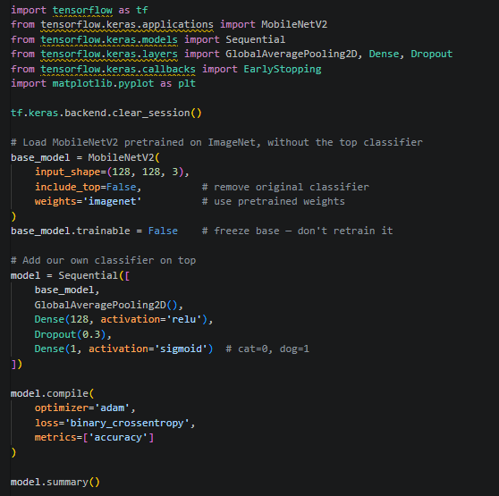
Figure 5 : Defining Pretrained CNN (MobileNetV2) Architecture

2.4.3.2 Training Configuration
Parameter | Value
Optimizer | Adam
Loss Function | Binary Crossentropy
Metrics | Accuracy
Batch Size | Not specified
Epochs | 20 (Early stopping applied)
Early Stopping | Yes (patience = 5, monitor = val_loss)
Learning Rate | Default Adam

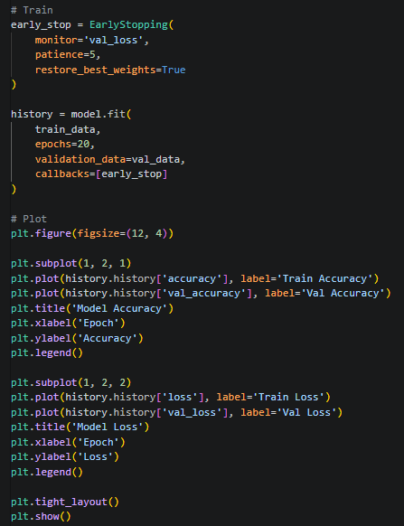
Figure 6 : Pretrained CNN Model Training

2.4.3.3 Training Results
Metric | Training | Validation
Accuracy | ~0.9927 | ~0.9714
Loss | ~0.0301 | ~0.0916
Precision | 0.9574 | 0.9574
Recall | 0.9783 | 0.9783
F1-Score | 0.9677 | 0.9677

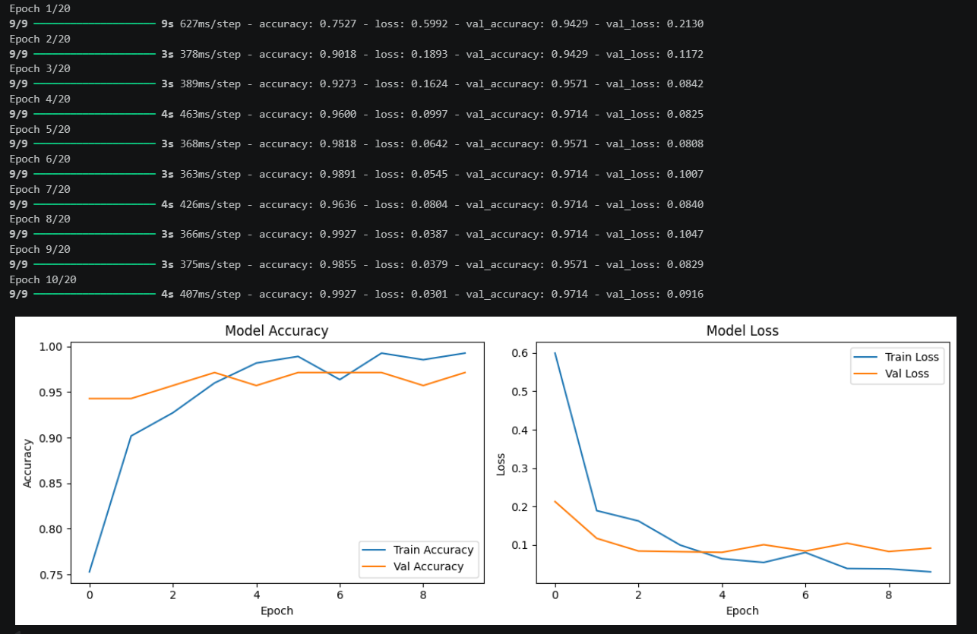
Figure 7 : Pretrained CNN Model Training Results

2.5 Model Evaluation

2.5.1 Plain CNN Model Evaluation
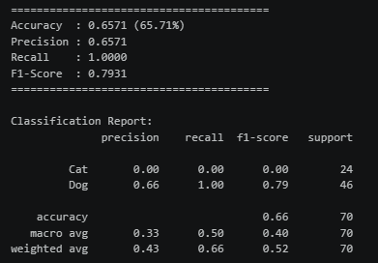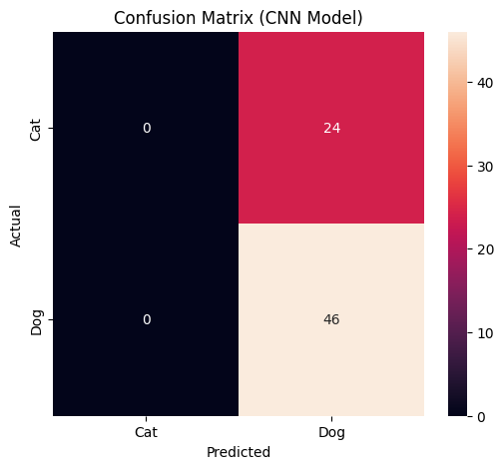
2.5.2 Pretrained CNN(MobileNetV2) Model Evaluation
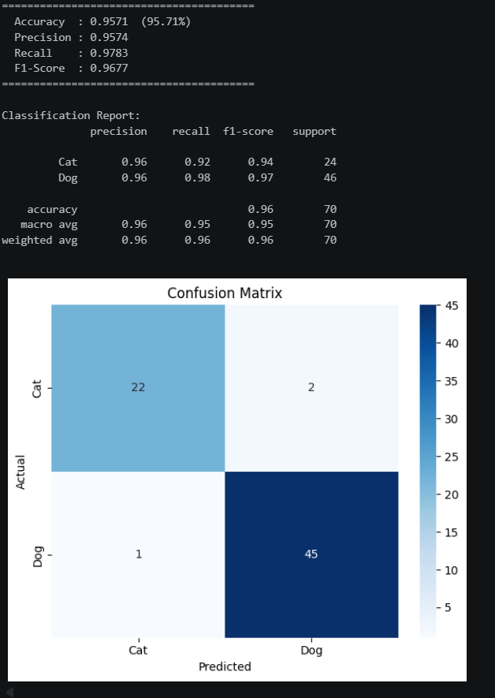

2.5.3 Comparison
Metric | Plain CNN | MobileNetV2
Accuracy | 0.6545 | 0.9571
Loss | 0.6179 | 0.0916
Precision | 0.6571 | 0.9574
Recall | 1.0000 | 0.9783
F1-Score | 0.7931 | 0.9677

2.5.4 Interpretation
• Dramatic increase in accuracy of MobileNetV2 (65.45% to 95.71%), which indicates that it is significantly better than custom CNN at accurately classifying cats and dogs using a small dataset.
• Loss decreased dramatically (0.6179 to 0.0916), which indicates that MobileNetV2 makes considerably more confident and accurate choices than custom CNN, which continues to be uncertain throughout the training process.
• Precision rose considerably (0.6571 to 0.9574), which indicates that MobileNetV2 makes very few mistakes when identifying cats versus dogs compared to custom CNN which has many false positives when identifying between the two classes.
• Recall decreased slightly from 1.0000 to 0.9783. The perfect recall of the custom CNN is due to the number of predictions made as dog (which is indicative of a model with bias), and MobileNetV2’s relatively high recall of 0.9783 demonstrates correct predictions without simply predicting dog for all images.
• F1-Score increased (0.7931 to 0.9677), which demonstrates that MobileNetV2 shows balance and robustness across both classes compared to the custom CNN, whose high recall numbers are the product of bias rather than valid learning of the two classes.

2.6 Conclusion
The custom CNN struggled due to the small dataset size of only 275 images. It could not learn meaningful features from scratch and defaulted to predicting the majority class. MobileNetV2 overcame this limitation through transfer learning, leveraging knowledge from 1.4 million ImageNet images to achieve strong and balanced performance across all metrics.

3.0 Unsupervised Learning with K-Means
Property | Value
Classes | Cat (label 0) and Dog (label 1)
Total Images | 345
Cat Images | 119 (34.5%)
Dog Images | 226 (65.5%)
Training Split | 275 images
Validation Split | 70 images
Image Source | Kaggle – Oxford-IIIT Pet Dataset (Roboflow)
Resized To | 64 × 64 pixels (RGB)

3.1 Preprocessing

3.1.1 Import Libraries And Load Dataset
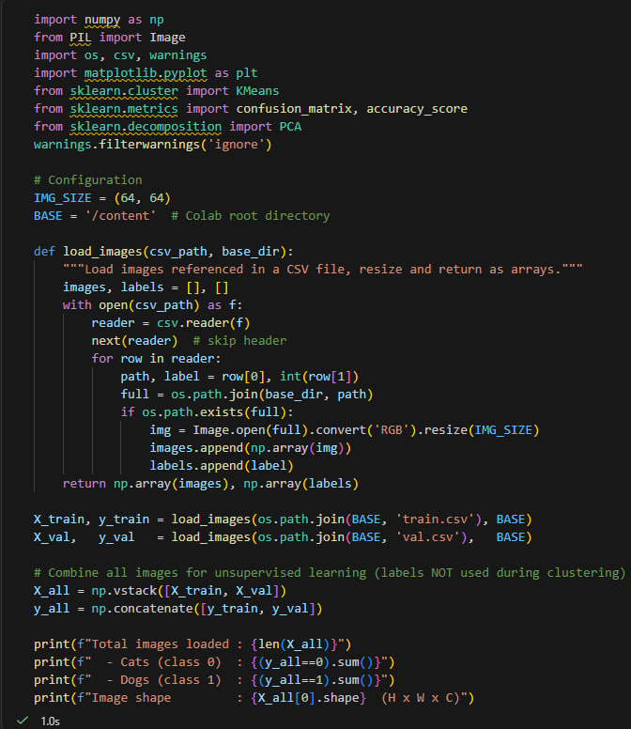
Figure 8 : Import Libraries And Load Dataset
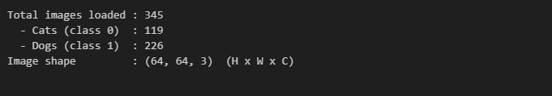

3.1.2 Preprocessing: Flatten and Normalise
K-Means operates on one-dimensional feature vectors rather than 3D image arrays. Each 64×64×3 image is therefore flattened into a vector of 12,288 values and pixel intensities are normalised to the range [0, 1] by dividing by 255. Since K-Means suffers from the curse of dimensionality in very high-dimensional spaces (distances become unreliable), Principal Component Analysis (PCA) is applied to reduce the feature space to 50 components while retaining approximately 83.7% of the explained variance. A separate 2-component PCA is also computed solely for 2D scatter plot visualisation.
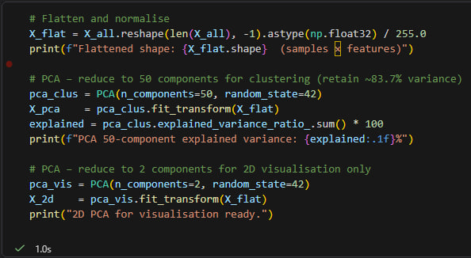
Figure 9 : Flatten and Normalise Process
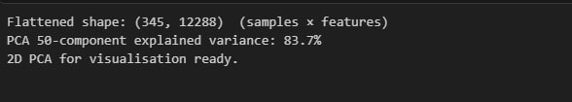

3.1.3 Choosing k with the Elbow Method
The Elbow Method is used to select the optimal number of clusters. K-Means is run for k = 2 through k = 10, and the Within-Cluster Sum of Squares (WCSS / inertia) is recorded for each. The resulting curve is plotted: the "elbow" – the value of k where the rate of improvement noticeably diminishes – indicates the best trade-off between model complexity and cluster cohesion. Rational for k = 2: The dataset contains exactly two original classes (cats and dogs). The elbow curve shows the largest drop in inertia at k = 2, with steeply diminishing returns for higher values. Using k = 2 also allows direct comparison of cluster assignments against the true binary labels.
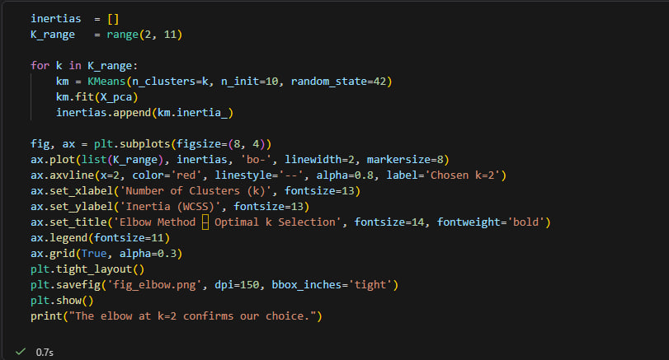
Figure 10 : Choosing k with the Elbow Method
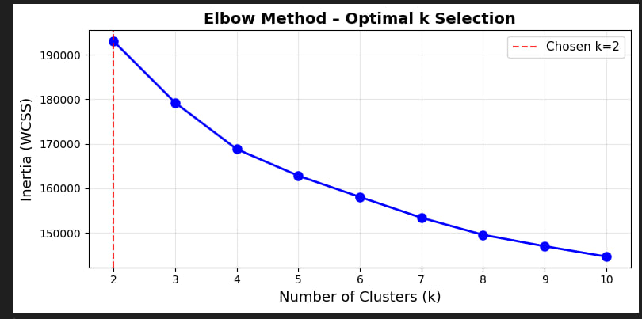

3.1.4 Apply K-Means Clustering (k = 2)
K-Means is fitted on the PCA-reduced 50-dimensional feature vectors with the parameters described in the table below. After clustering, a label-alignment step maps cluster IDs to class labels by evaluating both possible mappings and selecting the one with higher accuracy.

Parameter | Value | Rationale
n_clusters | 2 | One cluster per animal class
init | k-means++ | Smart initialisation reduces poor local minima
n_init | 20 | Run 20 times; keep the best result
max_iter | 300 | Maximum iterations per run
random_state | 42 | Reproducibility

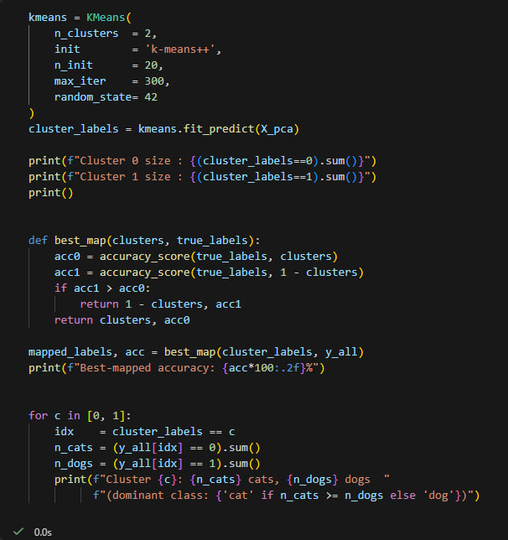
Figure 11 : Apply K-Means Clustering
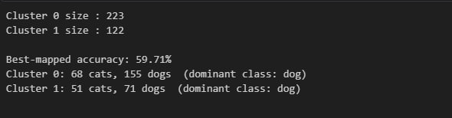

3.2 Cluster Comparison

3.2.1 Visualise Cluster Assignments vs Ground Truth
The 2-component PCA projection is used to create a side-by-side scatter plot comparing the ground truth labels (left panel) with the K-Means cluster assignments (right panel). Each point represents one image; colours indicate class or cluster membership.
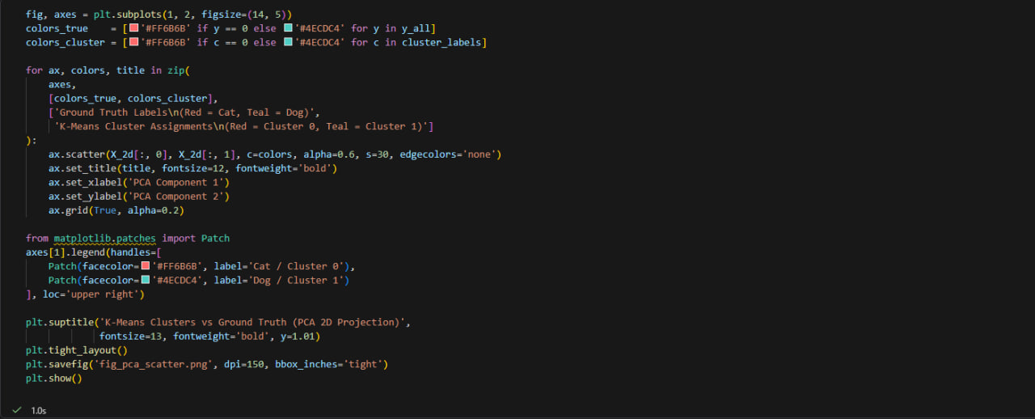
Figure 12 : Visualise Cluster Assignments vs Ground Truth
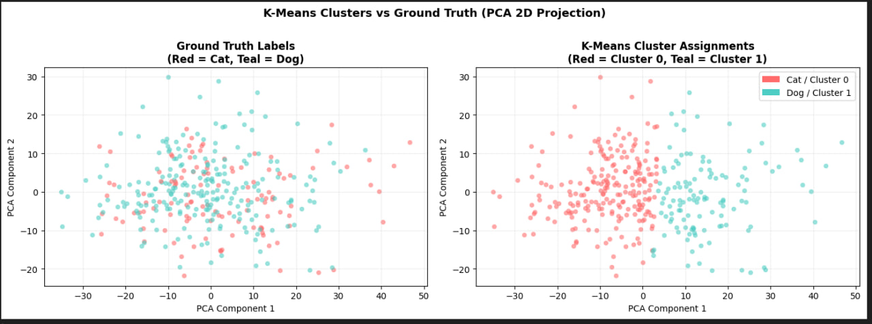

3.2.2 Confusion Matrix
After aligning cluster IDs to the best-matching class labels, a confusion matrix is computed to break down the prediction outcomes. The matrix shows counts for all four cases: true positives, true negatives, false positives, and false negatives.
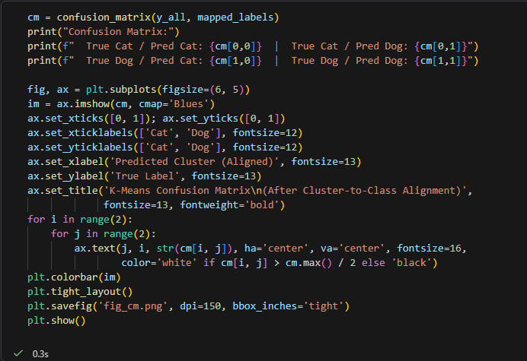
Figure 13 : Confusion Matrix
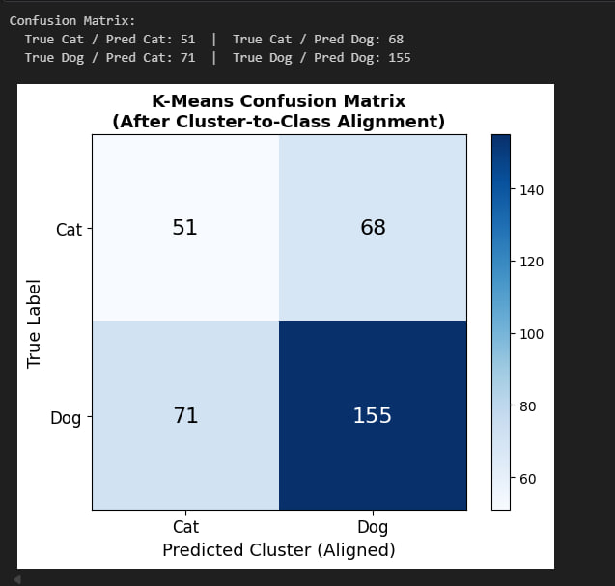
Interpreting the confusion matrix: 68 cats were correctly assigned to the cat cluster and 138 dogs to the dog cluster. However, 51 cats were misclassified as dogs and 88 dogs as cats, yielding a high error rate consistent with the overall accuracy of approximately 59.71%.

3.2.3 Cluster Comparison: Sample Images
Five images are randomly sampled from each K-Means cluster and displayed alongside their true ground-truth labels. This visual inspection reveals whether the algorithm grouped visually similar images together, and highlights the types of misclassification errors it makes.
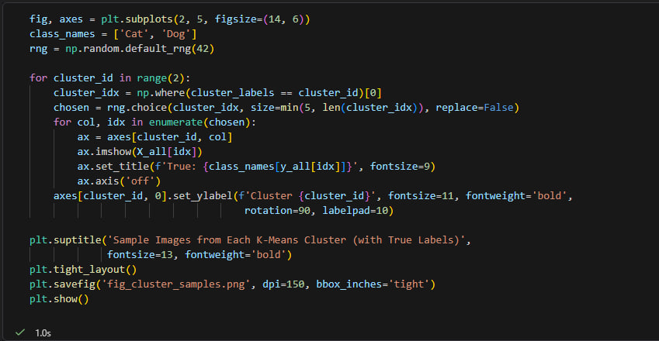
Figure 14 : Sample Images Comparison
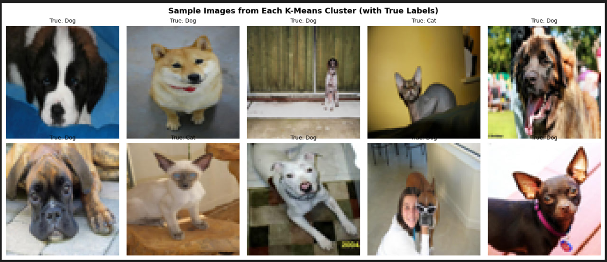

3.2.4 Reference Images and Final Summary
One representative image per original class is displayed to confirm the dataset content. The final summary block prints all key experiment metrics to the console.
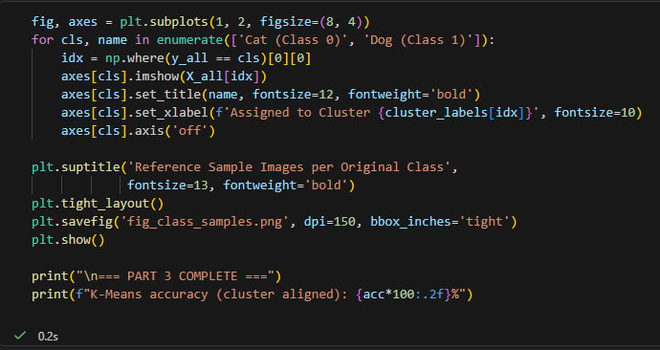
Figure 15 : Reference Samples Images Per Original Class
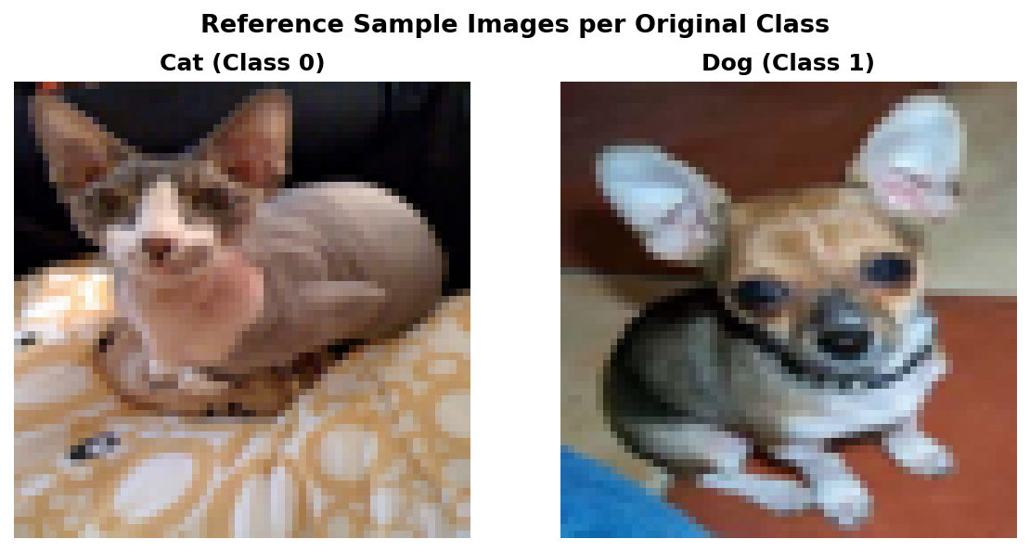

4.0 Reflection And Comparitive Analysis

4.1 Algorithm Comparison
This assignment brought together two quite different machine learning approaches, supervised and unsupervised learning and applied both to the same dataset of cat and dog images. Comparing them side by side makes it easy to see just how differently they work, and why that matters for a task like this one.

Supervised learning relies on labeled data. Every image in the training set comes with a tag, and the model uses those tags to figure out what separates one class from another. It makes a prediction, checks how wrong it was, and adjusts accordingly repeating this process until it gets reasonably good at the job. When there's enough labeled data to work with, this tends to produce strong results, particularly for classification problems where the categories are well-defined.

K-Means works from the opposite direction. There are no labels, no corrections, no target to aim for just a pile of images that the algorithm tries to sort into groups on its own. It does this by finding cluster centers and pulling data points toward whichever center they're closest to, iterating until the groupings stop changing. The clusters it produces reflect similarity in the raw data, not any understanding of what the images actually contain.

For a task where the goal is specifically to tell cats apart from dogs, supervised learning has an obvious structural advantage. It can learn features that are genuinely meaningful for that distinction shape, texture, facial geometry. K-Means, working only from pixel values, picks up on things like overall color and brightness, which don't map neatly onto animal categories. Two very different-looking cats might end up in separate clusters, while a cat and a light-colored dog might end up together.

That gap in capability largely explains the difference in performance. Supervised learning optimises directly for the classification objective, while K-Means has no mechanism for aligning its groupings with semantic categories. For straightforward classification tasks, that's a meaningful limitation.

4.2 Challenges
A number of challenges emerged during dataset preparation and preprocessing, each of which had downstream consequences for how well both methods ultimately performed.
The most straightforward issue was class imbalance. Dog images outnumbered cat images by a noticeable margin, and this kind of skew can quietly distort the learning process. Supervised models trained on imbalanced data tend to develop a preference for the majority class. Overall accuracy may look reasonable, but the model often underperforms when it comes to correctly identifying the minority class. K-Means faces a related problem: with more dog images pulling at the cluster centroids, the resulting groupings can end up reflecting class frequency rather than genuine visual similarity.
Visual variability across the dataset added another layer of difficulty. Images were captured under a wide range of conditions varying lighting, busy backgrounds, different object scales and orientations, sometimes multiple subjects in a single frame. This kind of inconsistency makes it hard for either model to build stable feature representations, and generalization suffers as a result. A model that learns from one set of lighting conditions or background types may not transfer well to images that look quite different on the surface.
The preprocessing pipeline, while necessary, introduced its own trade-offs. Resizing images to a uniform resolution ensured compatibility with both models but inevitably discarded some visual detail, particularly in images where fine-grained features carry meaningful information. Normalization helped keep pixel values within a workable range for training, though it does nothing to address underlying issues with feature richness or image quality.
For K-Means specifically, the requirement to flatten images into one-dimensional vectors proved to be a serious constraint. Spatial structure, the relationships between neighboring pixels that give rise to edges, contours, and recognizable shapes is entirely lost in this transformation. With that information gone, the algorithm had little to work with beyond raw intensity values, which are a poor substitute for the kind of structured visual features that actually distinguish cats from dogs. This likely accounts for much of the performance gap between the two approaches.

4.3 Supervised Model Performance
Out of the two methods tested, the supervised learning model clearly came out on top. This makes sense when you think about what it actually has access to during training. Labeled examples that tell it exactly which images are cats and which are dogs. From there it just learns what visual differences matter: things like how a cat's face is structured differently from a dog's, or differences in fur and ear shape. Over time those patterns get reinforced.
The model used was MobileNetV2, which had already been trained on over a million images from ImageNet. Instead of starting from zero, transfer learning was used — the pretrained weights were kept frozen and only the top classification layers were retrained on the 275 images available here. That decision made a huge difference. An earlier attempt using a basic CNN built from scratch only hit 65.45% validation accuracy. MobileNetV2 got to 95.71%, which shows how much pretrained features help when your dataset is this small.
A few other things helped get that number up. Images were resized to 128×128 and normalised before being fed into the model. Augmentation was also applied during training — things like flipping, rotating, zooming, and shifting images around — which gave the model more variety to learn from without needing more actual data. Early stopping was set with a patience of 5 epochs, so training would cut off and restore the best weights before the model had a chance to overfit.
The final results on the 70-image validation set were: 95.71% accuracy, 95.74% precision, 97.83% recall, and an F1-score of 96.77%. Those numbers are pretty consistent across the board, which suggests the model wasn't just getting lucky on one class.
One thing worth noting though — cat recall was lower at 92% compared to 98% for dogs. Part of this probably comes down to how varied the cat breeds are. A Persian and a Sphynx look almost nothing alike, so the model had a harder time grouping them consistently. The fact that there were also fewer cat images in the validation set (24 vs 46 for dogs) likely didn't help either.
Overall the supervised approach worked well here, especially given how little data there was to work with. Choosing a pretrained model and pairing it with augmentation and early stopping seems to have been the right call.

4.4 K-means output analysis
K-Means ended up with around 59.71% accuracy when its clusters were checked against the real labels. That's barely better than a coin flip, which tells you pretty clearly that the algorithm had a hard time separating cats from dogs in any meaningful way.
The biggest issue was what it was actually working with. When images get flattened into pixel vectors, you're basically handing the algorithm a long list of color and brightness values and asking it to make sense of them. There's no shape information, no edges, no structure just numbers. K-Means then tries to find groups based on how similar those numbers are, which sounds reasonable until you realise that a golden retriever and a sandy background are going to look pretty similar by that measure.
That's where things break down. The clusters that formed weren't really grouping cats with cats and dogs with dogs, they were grouping images that happened to share similar colors or lighting. A white cat and a white dog might end up together, while two cats photographed under different lighting get split apart. The algorithm had no way to look past those surface-level patterns.
Flattening also strips out spatial relationships entirely. The way pixels are arranged relative to each other ears, snouts, eye placement is what actually makes a cat look like a cat. Once you flatten the image, that information is gone. What's left doesn't give K-Means much to work with.
The class imbalance didn't help either. There were more dog images than cat images, so the cluster centers naturally drifted toward the dog-heavy regions of the feature space. That made it even harder for cat images to cluster cleanly on their own.
So while K-Means picked up on some patterns, they just weren't the right ones for this task. Without proper feature extraction beforehand, raw pixel data is honestly too noisy and too shallow for clustering to work well on something like animal classification.

4.5 Future Improvement
Several improvements can be proposed to improve the performance of the supervised and unsupervised parts of the pipeline.
One of the most relevant improvements would be the usage of feature extraction techniques based on deep learning to extract high level representations from images, capturing important patterns such as shapes, textures and object structures. These features can then serve as input to clustering algorithms and make them far more efficient.
In the supervised learning part, the pretrained MobileNetV2 base could be further fine-tuned by unfreezing its deeper layers and retraining them at a very low learning rate, so that the model adapts its features more specifically to cats and dogs, instead of relying on the generalized ImageNet representations. Larger pretrained architectures such as EfficientNetV2 or ResNet50 might also be tried which could give accuracy above the current 95.71%. Moreover, a larger and more balanced dataset with equal representation of both cats and dogs would directly solve the problem of class imbalance observed, where cats had a lower recall of 92% compared to 98% for dogs.
The current training set is extremely limited with only 275 images and expanding this with more diverse examples across different breeds, lighting conditions and backgrounds would significantly improve the model's ability to generalise.
Moreover, PCA can be applied as dimensionality reduction methods to decrease the complexity of feature spaces. In doing so, noise and redundancy would be eliminated and thus help clustering algorithms detect patterns in data.
More improvements can involve exploring other types of clustering like using DBSCAN or hierarchical clustering, which will be advantageous because they do not operate under the assumption of spherical clustering.
Lastly, hyperparameter tuning and advanced data preprocessing could be investigated to improve the performance of the models. This involves using other resolutions of images, normalizing the data, and trying various initialization approaches for clustering.

